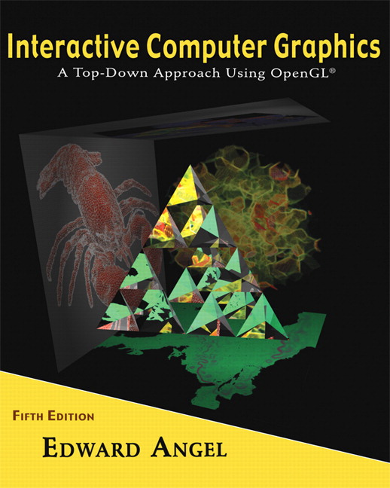 COSC 4370
Name: ____________________ TERMINAL # ____
Programming Assignment 2 Acceptance Testing:

After you downloaded your zipped project from BB and rebuilt it using the 200 PGH Visual Studio 2010, take screenshots of the output produced …….
1. Keyboard f so you can get the Front image of JURASIC PARK.
SCREENSHOT Output of your program is:
……..
Copy and Paste your gluLookAt here
……..
2. Keyboard b so you can get the Back image of JURASIC PARK.
SCREENSHOT Output of your program is:
……..
Copy and Paste your gluLookAt here
……..
3. Keyboard r so you can get the right Side image of JURASIC PARK.
SCREENSHOT Output of your program is:
……..
Copy and Paste your gluLookAt here
……..
4. Keyboard t so you can get the Top image of JURASIC PARK.
SCREENSHOT Output of your program is:
……..
Copy and Paste your gluLookAt here
……..
5. Keyboard i so you can get the Isometric image of JURASIC PARK.
SCREENSHOT Output of your program is:
……..
Copy and Paste your gluLookAt here
……..
6. Fly Through the JURASIC PARK from the front so you are in the middle of the JURASIC PARK, looking towards the front of the JURASIC PARK.
SCREENSHOT Output of your program is:
……..
7. Fly Through the JURASIC PARK from the front so you are in the middle of the JURASIC PARK, looking towards the back of the JURASIC PARK.
SCREENSHOT Output of your program is:
……..
8. Copy and Paste your .c (.cpp) file here:
…….
When done attach this file to “Testing Programming Assignment 2” BB assignment.

